**Viewing Questions: Our Planet Coastal Seas**

I recommend that you view this with the KELP FOREST ECOLOGY AND URCHIN BARRENS diagram that yours truly just made.

<https://www.youtube.com/watch?v=r9PeYPHdpNo&feature=share>

Start video at 19:00, though the first part is absolutely gorgeous, definitely worth a look…

Right away you get an update of the world’s coral reef status, shallow waters. What percentage of it is reported to have died? (a tropical context to what we will be exploring)

What are the two reasons why the latitudes poleward of the tropical coral reefs have coastal waters in some locales that are the most productive on the planet? (and you by know have seen some material on coastal upwelling, which is part of what narrator refers to as “storms.”)

Fur seals range along the North Pacific Rim from Japan, around to Alaska, and down all the way to Southern California.

In what state do we start out, and what season?

“These stands of giant kelp are as important to the oceans as ________ are to the __________.”

…”the dense canopy provides ____________ and ____________ for an abundant community.”

How high can giant kelp grow?

Note that the PNW coast has many kelp types, bull kelp among the most significant.

What mammal do we see now?

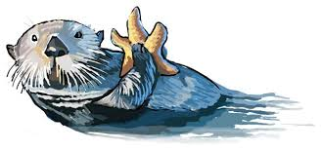

What makes it unique in the world?

What are a “favorite food?”

Why are these animals critical to the health of the kelp forest?

Who is a “helper” against these spiny grazers? (note that drawings below are of females)

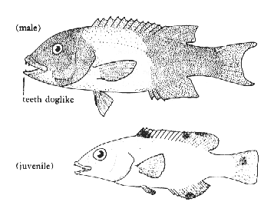

There are various names that this fish goes by, including the one given by the narrator, and also California sheepshead, and sheepshead fish. All start life as females, with the largest ones becoming males due to hormonal changes triggered by social cues, making them *protogynous*.

27:00: the grazing urchins are kept under control by these fish and otters, if they are in marine _________ _________ known as __________________. (Last word starts with an “s”)

What happens outside these areas? (thus my annotation about overfishing having reduced numbers of sheepshead fish in the system diagram)

One thing that I wish the documentary at this point would have done is to emphasize more one important point: that the marine areas near the sanctuaries can benefit enormously in the quantity, diversity and quality of life. Fisheries in such areas can be much improved when there is a healthy coastal kelp forest nearby that provides nursery habitat and sanctuary for so many fish. Healthy coral reefs play a similar role, my favorite one being in the Cabo Pulmo area in the southern part of the Sea of Cortez (Mexico). This area was way overfished, mostly by foreign vessels, but after there was a modest sized marine sanctuary established there, almost unbelievable things happened. I have swum in waters about three miles offshore in enormous schools of the gentle manta rays, some with over 2000 members. It is an experience that cannot be understood without directly experiencing it. I have seen 500 pound sea basses, a multitude of…

Note that the kelp forest of the Pacific Coast extends from Baja California, Mexico through Alaska. While the composition of the forests changes some over this vast expanse of latitude, the function of the ecosystem is remarkably similar throughout.

The third keystone predator in the kelp forest, in addition to *sea otters* and *sheepshead fish*, are *sunflower sea stars*, as you can see on the system diagram posted. They have historically extended from California into Alaska.

What is the theme of the herring section that starts at 28:40, in a global perspective? (respond after viewing for about 8 minutes.)

Eventually…”many of the worlds fish stocks are in ___________ _________________.” A _______ of them have ________________.”

In many coastal areas, what are taking over the waters?

What are the two closely related disadvantages of this change?

By about 37:30, then, quite gloomy. BUT…

What is described next, and where is the example? Explain the story.